OPPOSITION Nо B 3 220 648

Balenciaga, SAS, 16-18 rue Vaneau, 75007 Paris, France (opponent), represented by Santarelli, Tour Trinity 1 Bis, Place de la Défense, 92400 Courbevoie, France (professional representative)

a g a i n s t

Navima Calzados, S.L., C/ Charles Robert Darwin, Nº 28 (parque Tecnológico), 46980 Paterna, Spain (applicant), represented by Tecnopatent Propiedad Industrial, S.L., Miguel Ángel Cantero Oliva, 5-53, 28660 Boadilla del Monte, Madrid, Spain (professional representative).

On 24/03/2026, the Opposition Division takes the following

DECISION:

1. | Opposition No B 3 220 648 is upheld for all the contested goods, namely:

Class 18: Luggage, bags, wallets and other carriers; Trunks and suitcases.
Class 25: Clothing; Footwear [excluding orthopedic footwear]; Headgear; Parts of clothing, footwear and headgear; Footwear.
2. |  | European Union trade mark application No 19 014 263 is rejected for all the contested goods. It may proceed for the non-contested goods.

3. | The applicant bears the costs, fixed at EUR 620.

REASONS

On 23/07/2024, the opponent filed an opposition against some of the goods of European Union trade mark application No 19 014 263  (figurative mark), namely against some of the goods in Class 18 and all the goods in Class 25. The opposition is based on European Union trade mark registration No 17 416 141  (figurative mark). The opponent invoked Article 8(1)(b) EUTMR.

PROOF OF USE

In accordance with Article 47(2) and (3) EUTMR, if the applicant so requests, the opponent must furnish proof that, during the five-year period preceding the date of filing or, where applicable, the date of priority of the contested trade mark, the earlier trade mark has been put to genuine use in the territories in which it is protected in connection with the goods or services for which it is registered and which the opponent cites as justification for its opposition, or that there are proper reasons for non-use. The earlier mark is subject to the use obligation if, at that date, it has been registered for at least five years.

The same provision states that, in the absence of such proof, the opposition will be rejected.

The applicant requested that the opponent submit proof of use of the trade mark on which the opposition is based.

The request was submitted in due time and is admissible given that it was submitted as an unconditional request and in a separate document and the earlier trade mark was registered more than five years prior to the relevant date mentioned above.
The date of filing of the contested application is 16/04/2024. The opponent was therefore required to prove that the trade mark on which the opposition is based was put to genuine use in the European Union from 16/04/2019 to 15/04/2024 inclusive.

Furthermore, the evidence must show use of the trade mark for the goods on which the opposition is based, namely the following:

Class 18: Handbags, Wallets, Purses, Card cases (notecases), Beltbags; Backpacks,
Class 25: Clothing; Footwear; Headgear
According to Article 10(3) EUTMDR, the evidence of use must consist of indications concerning the place, time, extent and nature of use of the opposing trade mark for the goods or services in respect of which it is registered and on which the opposition is based.

On 17/02/2025, in accordance with Article 10(2) EUTMDR, the Office gave the opponent until 22/04/2025 to submit evidence of use of the earlier trade mark. This time limit was further extended until 22/06/2025 (Sunday). On 23/06/2025, within the time limit, the opponent submitted evidence of use.

Furthermore, prior to the proof-of-use request, the opponent had submitted evidence on 29/11/2024 in support of the enhanced distinctiveness’s claim. This evidence will also be taken into account for assessing the use of the earlier trade mark.

*
Therefore, the evidence to be taken into account is the following:

Evidence submitted on 29/11/2024

• Annex 1: 4 articles from the websites www.wikipedia.org, www.kering.com (Business Group of the opponent), www.vogue.com and www.italist.com, undated or bearing dates between 2015 and 2024, providing information about the history of the mark Balenciaga and its founder.

• Annex 2: articles from the websites www.kering.com (dated 07/10/2015), www.theguardian.com (dated 6/02/2018), www.standard.co.uk. (dated 3/03/2019), www.vogue.com (dated 4/03/2018) and www.businessoffashion.com (dated between 2019 and 2024) which provides information about the nomination of Demna Gvasalia as Artistic Director of the House Balenciaga, his work, creative approach and awards.

• Annex 3: Lyst Index rankings of fashion’s hottest brands and products, of quarter 2 of 2018, quarter 3 of 2019, quarter 4 of 2020, quarters 1, 3 and 4 of 2021, and quarters 1, 2 and 3 of 2022. The mark “Balenciaga” appears within the top four positions of the referenced rankings, first in the fourth quarter of 2021 and subsequently in the first quarter of 2022. This Annex also includes a selection of 13 articles from, inter alia, Vogue, Business Insider, StyleDemocracy, Robb Report, and Hypebeast, published between 2015 and 2022, which provide information on the aforementioned rankings and, more broadly, on the commercial success of Balenciaga. The earlier mark appears on, inter alia, the following footwear:

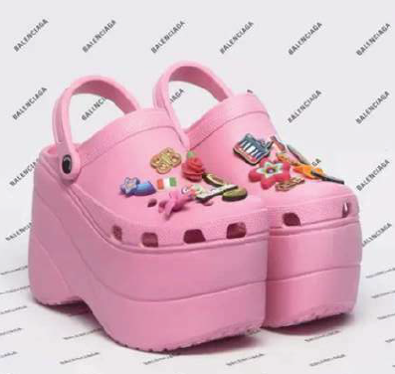

• Annex 4: undated screenshots of multi-brand stores websites showing the sale of the opponent’s fashion goods, in particular bags, clothing, footwear and headgear: Printemps (France), Fashion Clinic (Portugal), STEFFL (Austria), Louisa Via Roma (Italy), Galeries Lafayette (France). Here some examples of goods bearing the earlier mark:

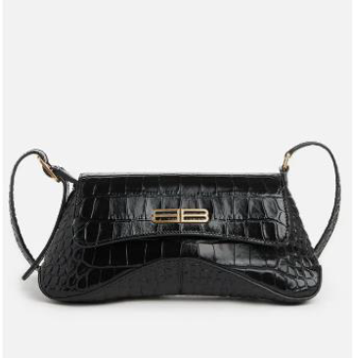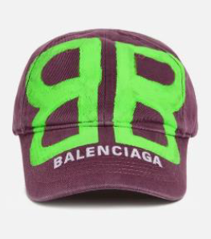
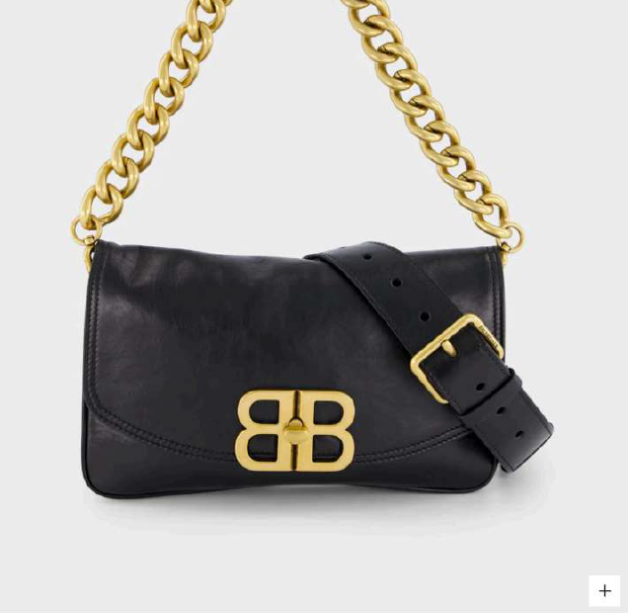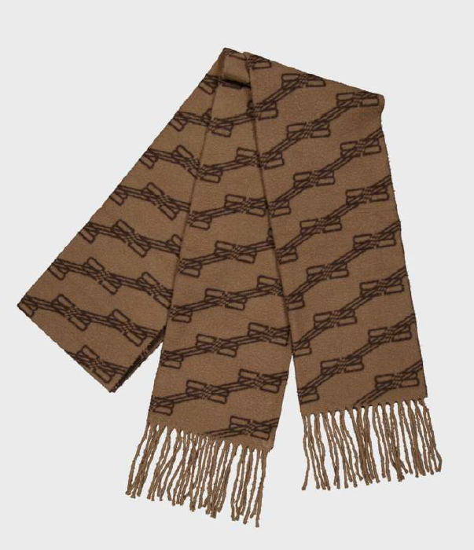

• Annex 5: extract from the Opponent’s French website showing products bearing the earlier mark, or variations thereof, in particular, belts, bags, card cases, wallets, hats, shoes and some clothing. Below, some examples:

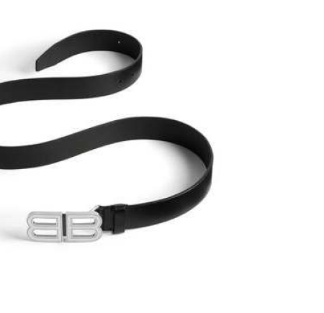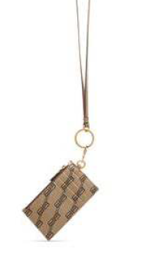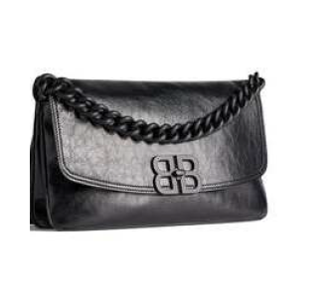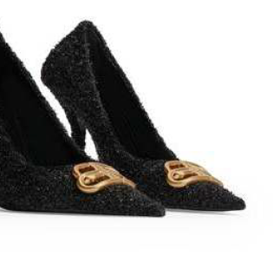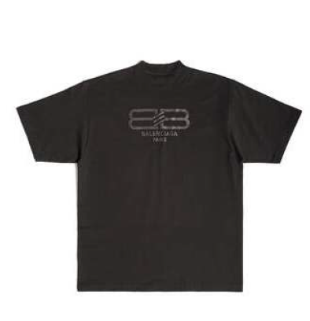

• Annex 6: 5 first pages of results on a search through Google® Image on « bb balenciaga ». The results show products such as the following:

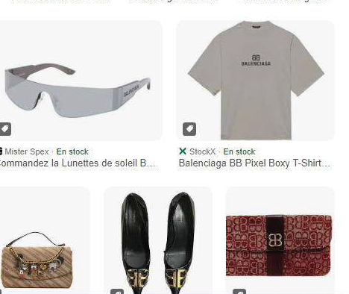

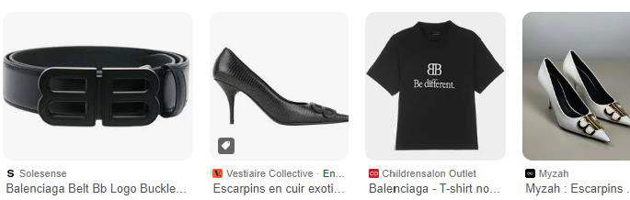

• Annex 7: first pages of the Opponent’s social media Instagram and Facebook which show 14.4 million and 2.6 million of followers, respectively.

• Annex 8: extracts from Balenciaga’s YouTube channel, together with a selection of twelve articles from the European press, written in French (partially translated) and English, published between 2016 and 2024, concerning Balenciaga’s various fashion shows.

• Annex 9: a selection of 9 press articles between 2015 and 2022 and reporting some advertising campaigns of Balenciaga. The earlier mark appears on some goods advertised such as:



• Annex 10: opponent’s European Union press book, comprising magazines from various EU countries, including France, Italy, Germany, and Spain, published between 2017 and 2024, showing different advertisements for goods in Classes 18 and 25. The earlier mark appears on some of these goods, as shown below:

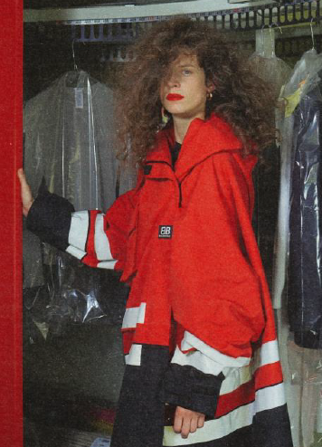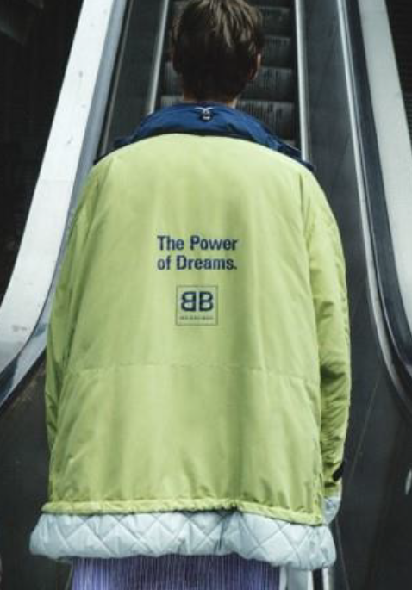

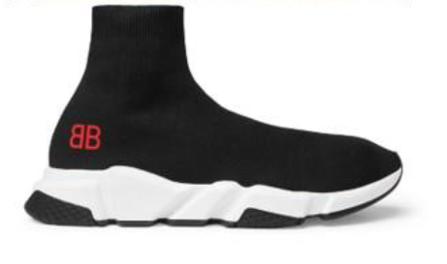

• Annex 11: opponent’s newsletters and press articles of 2023 and 2024 related to some of Balenciaga’s famous ambassadors.

• Annex 12: several articles dated between 2018 and 2024 showing pictures of celebrities and influencers wearing products bearing the earlier mark, namely some pieces of jewellery and clothing garments. It also includes some screenshots from celebrities’ social media profiles.

• Annex 13: online articles concerning the “Hacker Project” collaboration between Balenciaga and Gucci, a collaboration carried out for the creation and commercialization of bags. These articles include, inter alia, the following statements:

▪ ‘our brain is already trained to associate a signature silhouette following a recognizable monogram, and when two get amalgamated, so do our brains too’
▪ ‘Balenciaga has also made many headlines introducing a few pieces on its sites so far. And most of them are sold out, such as ‘BB’ monogram socks, being ‘BB’ monogram cap and ‘BB’ monogram puffer coats.’
▪ ‘we all know how famous Gucci and Balenciaga are’, ‘These amalgamations of two prominent brands’
▪ ‘It should come as no surprise that Hacker Project accessories are quite literally flying off the shelves’.

• Annex 14: online articles dated from 2017 to 2022 presenting Balenciaga’s mark and highlighting its products, especially the t-shirts, sweaters, watches, jewellery, bags and shoes. The earlier mark appears on some of the products shown such as:

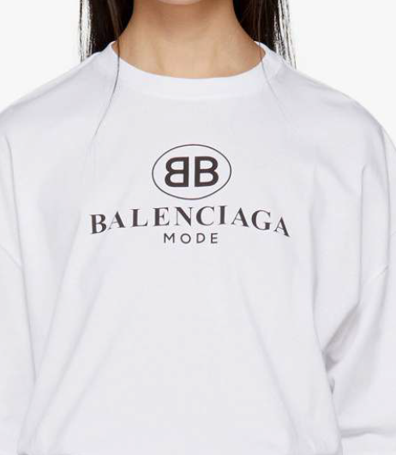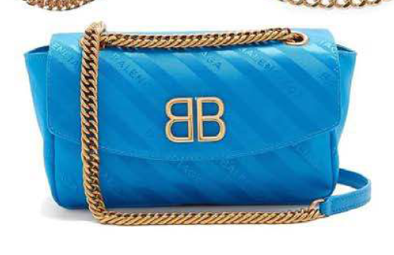

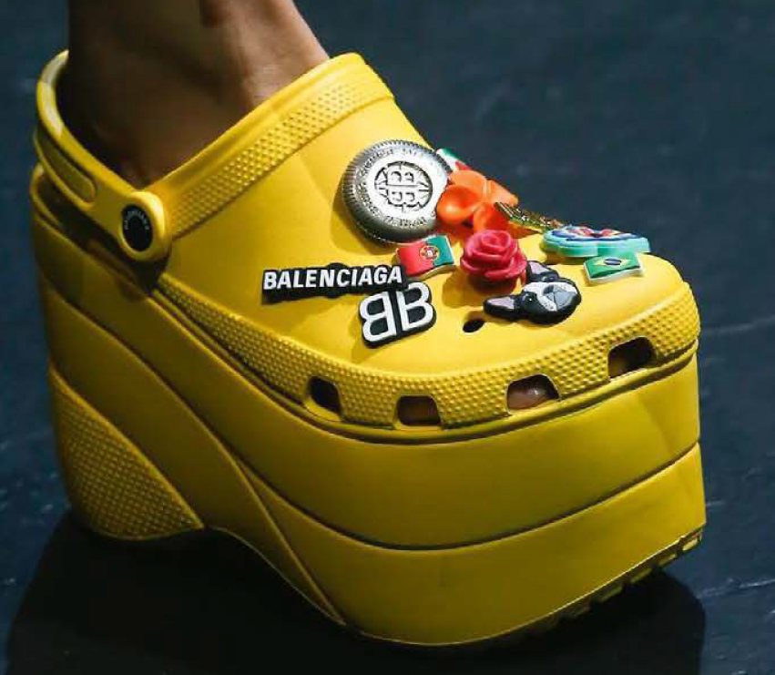

• Annex 15: online articles dated between 2017 about the history and reputation of the earlier mark and some screenshots from websites offering goods bearing the earlier mark. The articles include, inter alia, the following statements:

▪ ‘while the legendary flipped double B remain, this Georgian designer brought a number of unexpected logos that became emblems (...) On jackets, scarves, nail art on models or shoes, they were everywhere’.
▪ ‘we dive into the nuances of some of the most recognizable logos (…) Balenciaga’s BB logo dates back to the ‘80s and ‘90s, when it appeared on the brand’s garment tags’.
▪ ‘the iconic stitched ‘B’s are still used by the brand, but more often another combinator be seen, two letters back to back with no connecting lines’.

• Annex 16: screenshots from the social media platform (PINTEREST) showing the earlier mark, where the posts refer to it as a 'luxury brand' or as 'les logos des plus grandes marques de luxe françaises', along with examples of products bearing the earlier mark.

• Annex 17: online articles about the collaboration between Balenciaga and Fortnite. The images show virtual characters bearing garments with the earlier mark, as shown below:



• Annex 18: Online articles, including entries from Wikipedia and third-party websites, relating to the appearance of the ‘Balenciaga’ mark and the ‘BB’ mark in an animated short film based on the television series The Simpsons.

• Annex 19: Examples of product placement dated between 2018 and 2024 for products bearing the earlier mark.

Evidence submitted on 23/06/2025

• Item A: images of leather goods bearing the earlier mark, or some variations thereof, namely bags, wallets, card holders and backpacks. The document contains a description of the product, together with some images of European websites offering the product and the hyperlink of the corresponding website. Below some examples:

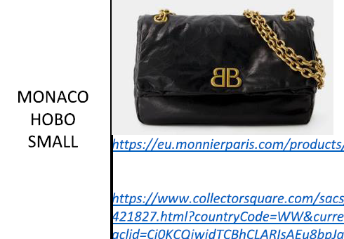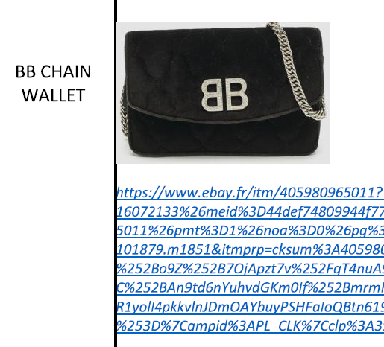

• Item B: summary table of invoices issued to clients in certain EU countries, including Germany, Italy, and France, dated between 2019 and 2022, together with the corresponding invoice samples and images of the products as displayed on the relevant websites. The products shown correspond to bags.

• Item C: images of clothing and headgear bearing the earlier mark, or some variations thereof. The document contains a description of the product, together with some images of European websites offering the product and the hyperlink of the corresponding website. Below some examples:

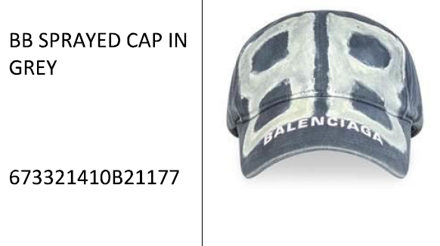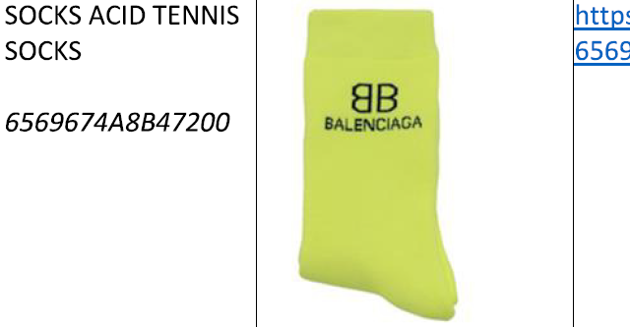

• Item D: images of footwear bearing the earlier mark, or some variations thereof. The document contains a description of the product, together with some images of European websites offering the product and the hyperlink of the corresponding website. Below some examples:

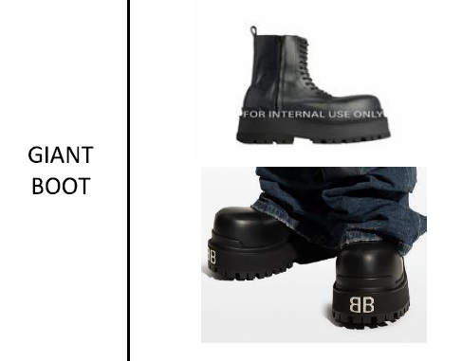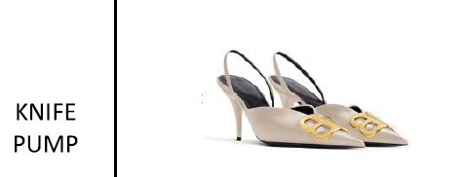

• Item E: summary tables of invoices issued to clients in certain EU countries, including Germany, Italy, France, and Spain, dated between 2019 and 2024, together with the corresponding invoice samples and screenshots—some of which were extracted using the Wayback Machine—showing the products as displayed on the relevant websites during the corresponding period. The products shown include, inter alia, clothing and headgear. Below some examples:

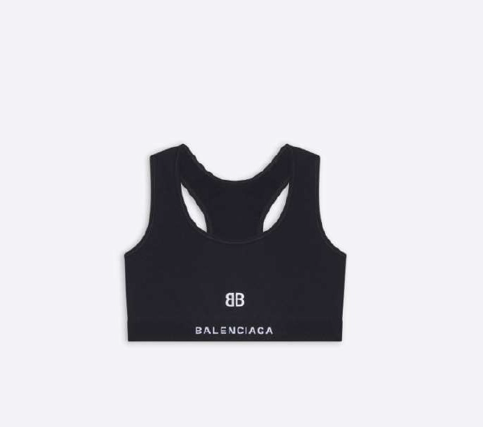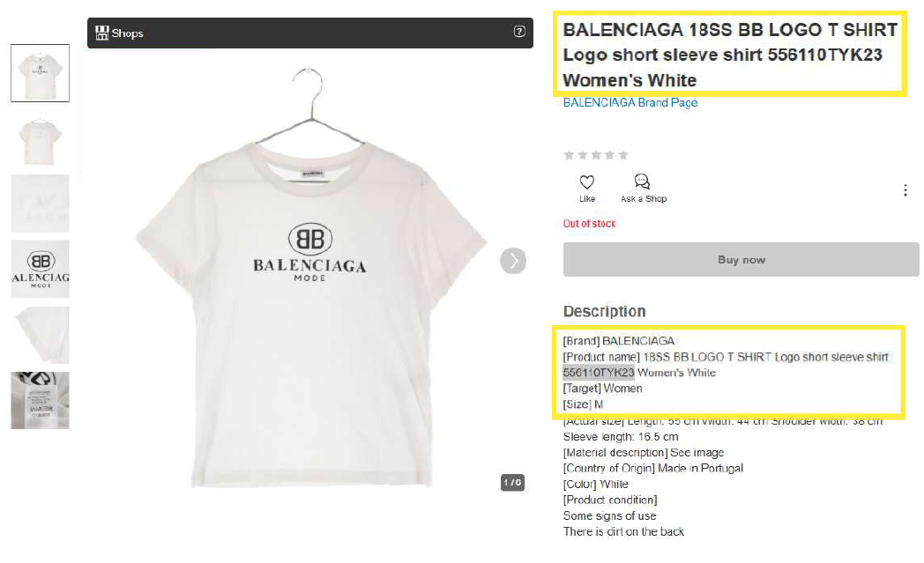

• Item F: summary tables of invoices issued to clients in certain EU countries, including Germany, Italy or France, dated between 2019 and 2024, together with the corresponding invoice samples and screenshots—some of which were extracted using the Wayback Machine—showing the products as displayed on the relevant websites during the corresponding period. The products shown are footwear. Below an example:

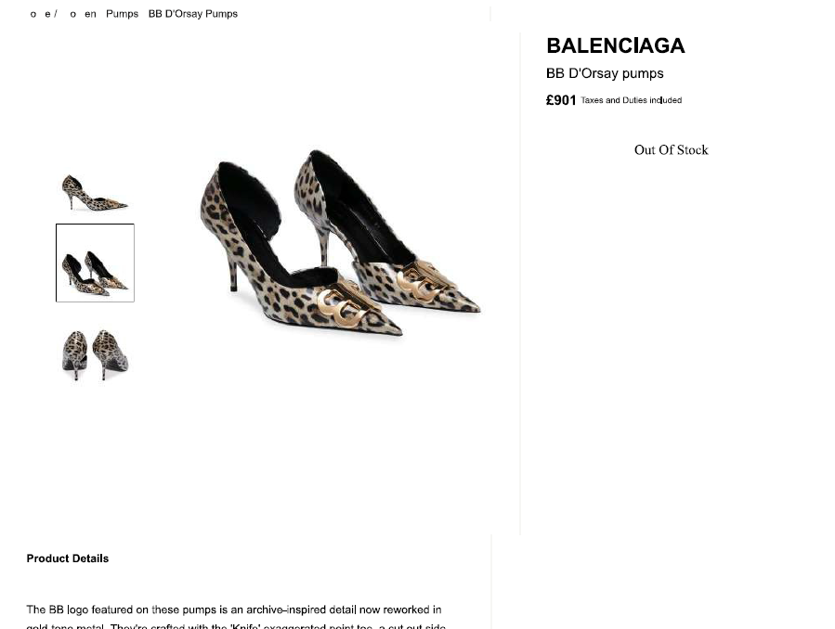

• Item G: extracts from third-party websites offering, under their respective brands, various items of clothing, bags, handbags, and wallets.

The applicant argues that not all the items of evidence indicate genuine use in terms of time, place, extent, nature and use of all the goods for which the earlier mark is registered.

The applicant’s argument is based on an individual assessment of each item of evidence regarding all the relevant factors. However, when assessing genuine use, the Opposition Division must consider the evidence in its entirety. Even if some relevant factors are lacking in some items of evidence, the combination of all the relevant factors in all the items of evidence may still indicate genuine use.

Analysis of the proof of use

Place of use

The invoices, online articles, screenshots of advertisements published in magazines, and press coverage demonstrate that the earlier mark has been used within the European Union, in particular in France, Germany, and Italy. This is evidenced by the addresses indicated on the invoices, the language used in the online articles and magazines, and the country-code top-level domains displayed on the online platforms offering the relevant goods. Accordingly, the submitted evidence relates to the relevant territory.

Time of use

Although part of the evidence is undated, the sale invoices, the majority of the online articles and some of the advertising materials and extracts from the Wayback machine are dated within the relevant period. Considering the above, the Opposition Division finds that the time of use requirement has been met.

Extent of use

All the relevant facts and circumstances must be taken into account as regards extent of use, including the nature of the relevant goods or services and the characteristics of the market concerned, the territorial extent of use, and its commercial volume, duration and frequency.

It must be assessed whether, in light of the market conditions in the relevant sector or trade, the evidence submitted allows the conclusion that the proprietor has made a genuine effort to establish a commercial presence in the relevant market.

The information submitted by the opponent, supported by invoices, online articles referring to the earlier mark as an “iconic” or “recognisable” monogram, screenshots of advertisements published in magazines, press coverage, and examples of goods bearing the earlier mark offered through multiple online commercial platforms, demonstrates that the earlier mark was used on a regular basis in the European Union during the relevant period. Although, as the applicant claims, some of the printouts, only indicate the date of extraction, it is evident from the overall set of invoices dated within the relevant period, as well as from online articles and publications showing images of products bearing the earlier mark, such as Annexes 3, 10, 13, and 14, that the goods were commercialized throughout the relevant period.

Although information regarding the commercial volume of the goods can be primarily derived from the invoices submitted by the opponent, the number of items sold therein is relatively substantial. Moreover, the evidence as a whole shows that the goods were offered and sold regularly throughout the entire relevant period. It should be noted that the purpose of the requirement of genuine use of an earlier mark is not to assess the commercial success of the undertaking concerned (08/07/2010, T-30/09, peerstorm/PETER STORM, EU:T:2010:298, § 43).

In view of the foregoing, the Opposition Division finds that the opponent has provided sufficient indications as to the extent of use of the earlier mark in the European Union.

Nature of use

In the context of Article 10(3) EUTMDR, the expression ‘nature of use’ includes evidence of use of the sign in accordance with its function, of use of the mark as registered, or of a variation thereof according to Article 18(1), second subparagraph, point (a) EUTMR, and of its use for the goods and services for which it is registered.

The evidence clearly shows that the earlier mark has been used in accordance with the function to guarantee the identity of the origin of the opponent’s goods for which they are registered. The mark appears, as registered, placed on, or in connection of, various types of clothing, headgear and protective clothing etc.

Article 18(1)(a) EUTMR provides that, apart from use of the mark in its registered form, use of the trade mark in a form differing in elements that do not alter the distinctive character of the mark as registered also constitutes ‘use of the trade mark’. This applies regardless of whether the mark as used is also the subject of a separate trade mark registration of the proprietor. The purpose of this provision is to allow the proprietor, in the commercial exploitation of the mark, to make variations in the mark that, without altering its distinctive character, enable it to be better adapted to the marketing and promotion requirements of the goods or services concerned (23/02/2006, T-194/03, Bainbridge (fig.) / Bridge et al., EU:T:2006:65, § 50).

The applicant claims that ‘some models as Monaco clutch and bags, Clutch Maxi or Flap bags include a depiction different to that registered’ and that ‘regarding clothes and garments, all inclusion of’ the earlier mark ‘is accompanied by other elements as BALENCIAGA or other ornamentation’.

As to the variations of the earlier mark, although some pieces of evidence depict the mark in a different stylization, the majority of the evidence presents the mark in its registered form, for example, Annexes A, C, D, and E. Accordingly, the evidence as a whole sufficiently demonstrates that the earlier mark was used in its registered form during the relevant period.

Furthermore, trade marks are often used together with other marks, for example, to indicate a house mark and a sub-brand. This constitutes use of a mark in the same form as registered, in parallel with, but independently from, other marks (simultaneous use of independent marks). This is different from use of a mark in a different form than the one registered (08/12/2005, T‑29/04, Cristal Castellblanch, EU:T:2005:438, § 33, 34; 06/11/2014, T‑463/12, MB, EU:T:2014:935, § 43). Consequently, in the case of simultaneous use of independent marks, the question of whether the distinctive character of the mark as registered has been altered does not even arise and Article 18(1)(a) EUTMR is not applicable. Accordingly, use of a mark without any modification, including simultaneous use with separate, independent marks, is covered by the first subparagraph of Article 18(1) EUTMR, not by Article 18(1)(a) EUTMR.

To establish simultaneous use, what has to be determined is whether the marks in question, despite being used together, remain independent from each other and whether they will be perceived in this way by the public. This is in contrast to where the public will instead perceive them as forming a unit and not as ‘separate, independent marks’.

In this regard, it is evident that the earlier mark, and the element ‘BALENCIAGA’ are not perceived as forming a single unitary sign but rather as two independent trade marks used simultaneously. This is corroborated by the submitted articles, which refer to Balenciaga’s monogram as a distinct and recognisable sign. Moreover, the use of the earlier mark in connection with ‘BALENCIAGA’ on certain products, or on its own, in advertising, and in online commerce demonstrates that the monogram has been actively used as an identifier of the goods, thereby confirming genuine use of the earlier mark in its registered form.

Taking into account the evidence in its entirety, it is sufficient to prove genuine use of the earlier trade mark in relation to all the relevant goods during the relevant period and in the relevant territory.

LIKELIHOOD OF CONFUSION — ARTICLE 8(1)(b) EUTMR
Pursuant to Article 8(1)(b) EUTMR, a likelihood of confusion exists if there is a risk that the public might believe that the goods or services in question, under the assumption that they bear the marks in question, come from the same undertaking or, as the case may be, from economically linked undertakings. Whether a likelihood of confusion exists depends on the appreciation in a global assessment of several factors, which are interdependent. These factors include the similarity of the signs, the similarity of the goods and services, the distinctiveness of the earlier mark, the distinctive and dominant elements of the conflicting signs, and the relevant public.

a) The goods

The goods on which the opposition is based, and for which genuine use has been proven, are the following:

Class 18: Handbags, wallets, purses, card cases (notecases), beltbags; backpacks.
Class 25: Clothing; footwear; headgear; belts [clothing].
The contested goods are the following:

Class 18: Luggage, bags, wallets and other carriers; Trunks and suitcases.
Class 25: Clothing; Footwear [excluding orthopedic footwear]; Headgear; Parts of clothing, footwear and headgear; Footwear.
The relevant factors relating to the comparison of the goods or services include, inter alia, their nature, their intended purpose, their method of use and whether they are in competition with each other or are complementary (‘the Canon criteria’). It is also necessary to take into account, besides the Canon criteria, other factors, namely distribution channels, the relevant public and the usual origin of the goods or services (02/06/2021, T‑177/20, Hispano Suiza / Hispano Suiza, EU:T:2021:312, § 21-22).
Contested goods in Class 18

The contested wallets are identically included in both list of goods.
The contested bags and other carriers include, as broader categories, the opponent’s handbags. Since the Opposition Division cannot dissect ex officio the broad categories of the contested goods, they are considered identical to the opponent’s goods.
The contested luggage; trunks and suitcases are similar to the opponent’s handbags as they usually coincide in producer, relevant public and distribution channels.
Contested goods in Class 25

The contested clothing; footwear [excluding orthopedic footwear]; headgear; footwear are identically included in both list of goods (including synonyms).

The contested parts of clothing, footwear and headgear are similar to the opponent’s clothing; footwear; headgear. Clothing includes brassieres and parts of clothing include goods such as bra straps, which are usually removable and can be sold separately. Therefore, the goods at issue can target the same relevant public, share the same distribution channels and be produced by the same undertakings. Furthermore, they can also be complementary to each other. In addition, parts of footwear include goods such as inner soles which are removable and can be sold separately from footwear. Therefore, the goods at issue can target the same relevant public, share the same distribution channels and be complementary to each other. Moreover, headgear includes caps and parts of headgear include goods such as neck flaps, which can be sold separately as detachable parts of caps. Therefore, the goods at issue can target the same relevant public, share the same distribution channels and be produced by the same undertakings. Furthermore, they can also be complementary to each other.

b) Relevant public — degree of attention

The average consumer of the category of products concerned is deemed to be reasonably well informed and reasonably observant and circumspect. It should also be borne in mind that the average consumer’s degree of attention is likely to vary according to the category of goods or services in question (22/06/1999, C-342/97, Lloyd Schuhfabrik, EU:C:1999:323, § 26).
In the present case, the contested goods found to be identical or similar target the general public (e.g. clothing) or the general public and professional public (e.g. parts of clothing, footwear and headgear) and the earlier goods target the general public exclusively. Therefore, the relevant public for assessing likelihood of confusion will be the general public only (14/07/2005, T-126/03, ALADIN / ALADDIN, EU:T:2005:288, § 81).

The degree of attention is considered average.

c) The signs

Earlier trade mark | Contested sign

The relevant territory is European Union.

The global appreciation of the visual, aural or conceptual similarity of the marks in question must be based on the overall impression given by the marks, bearing in mind, in particular, their distinctive and dominant components (11/11/1997, C‑251/95, Sabèl, EU:C:1997:528, § 23).

The earlier mark will be perceived as letters 'B' in a rather standard font positioned adjacent to each other, with one facing left and one facing right. As these letters have no connection with the goods, they have a normal degree of distinctiveness.

The contested sign will be perceived by the substantial part of the relevant public as composed of a combination of two letters 'B', with one facing left and one facing right, where each letter is defined by two outer lines forming a double-contour outline, with a thick vertical line positioned centrally between the letters. Nevertheless, it cannot be excluded that a minor part of the relevant public may not associate the contested sign's figurative element with any particular letter. In any event, this element has no connection with the goods and therefore has a normal degree of distinctiveness. Since it is not necessary to establish that there is a likelihood of confusion for the whole of the relevant public (20/07/2017, T-521/15, D (fig.) / D (fig.) et al., EU:T:2017:536, § 69), the following comparison will be carried out in relation to the substantial part of the public, which perceives both signs as composed of two letters 'B'.

The length of the signs may influence the effect of the differences between them. The shorter a sign, the more easily the public is able to perceive all of its single elements. Therefore, in short words, small differences may frequently lead to a different overall impression (13/09/2023, T‑473/22, LAAVA (fig.) / Lav (fig.) et al., EU:T:2023:543, § 51; 26/04/2023, T‑153/22, XTG (fig.) / Gtx, EU:T:2023:217, § 39). In contrast, the public is less aware of differences between long signs.

Visually, both signs share the same basic structure: two letters 'B' arranged adjacently in a mirrored configuration, with one facing left and the other facing right. The signs differ, however, in their stylisation. The earlier mark is written in a standard bold font, while the contested sign renders each letter through a double-contour outline with a central thick vertical line. Despite this difference, the common underlying structure of two mirrored letters B remains recognisable in both signs.

Therefore, the signs are visually similar to a below-average degree.

Aurally, the pronunciation of the signs coincides as both will be perceived as composed of two letters ‘B’.

Therefore, the signs are aurally identical.

Conceptually, neither of the signs conveys a meaning for the public in the relevant territory. Since a conceptual comparison is not possible, the conceptual aspect does not influence the assessment of the similarity of the signs.

d) Distinctiveness of the earlier mark

The distinctiveness of the earlier mark is one of the factors to be taken into account in the global assessment of likelihood of confusion.

According to the opponent, the earlier trade mark enjoys a high degree of distinctiveness as result of its long standing and intensive use in the European Union in connection with all the goods for which it is registered, namely:

Class 18: Handbags, Wallets, Purses, Card cases (notecases), Beltbags; Backpacks.

Class 25: Clothing; Footwear; Headgear; Belts [clothing].

This claim must be properly considered given that the distinctiveness of the earlier trade mark must be taken into account in the assessment of likelihood of confusion. Indeed, the more distinctive the earlier mark, the greater will be the likelihood of confusion, and therefore marks with a highly distinctive character because of the recognition they possess on the market, enjoy broader protection than marks with a less distinctive character (29/09/1998, C-39/97, Canon, EU:C:1998:442, § 18).

The enhanced distinctiveness of the earlier trade mark should exist at the time of filing of the contested EUTM application (or any priority date). In principle, it is sufficient that the opponent show that its mark had acquired enhanced distinctiveness on that date. Enhanced distinctiveness should also exist at the time when the opposition decision is taken. However, in principle, this will be assumed unless the applicant claims and proves any subsequent loss of enhanced distinctiveness.

In the present case, the contested trade mark was filed on 16/04/2024. Therefore, the opponent was required to prove that the trade mark on which the opposition is based had a reputation and enjoyed a high degree of distinctiveness as result of long standing and intensive use prior to that date.

The evidence submitted by the opponent to prove the reputation and highly distinctive character of the earlier trade mark has already been listed above in the section ‘Proof of use’. As mentioned there, some of the evidence submitted by the opponent was filed after the date of substantiation.

However, even though, according to Article 7(2) EUTMDR, the opponent has to provide evidence of substantiation within a time limit set by the Office, this cannot be interpreted as automatically preventing additional evidence from being taken into account.

According to Article 8(5) EUTMDR, where after the expiry of the period referred to in Article 7(1) EUTMDR, the opponent submits facts and evidence that supplement relevant facts or evidence submitted within that period and that relate to the same requirement laid down in Article 7(2) EUTMDR, the Office has to exercise the discretion conferred on it by Article 95(2) EUTMR in deciding whether to accept these supplementing facts or evidence. The Office must exercise its discretionary power if the late facts or evidence merely supplement, strengthen and clarify the prior relevant evidence submitted within the time limit that relate to the same legal requirement laid down in Article 7(2) EUTMDR, namely, when both sets of facts or evidence refer to the same earlier mark, to the same ground and, within the same ground, to the same requirement.

In exercising its discretion, the Office must take into account, in particular, the stage of proceedings and whether the facts or evidence are, prima facie, likely to be relevant for the outcome of the case and whether there are valid reasons for the late submission of the facts or evidence. The acceptance of additional belated evidence is unlikely where the opponent has abused the time limits set by knowingly employing delaying tactics or by demonstrating manifest negligence.

In this regard, the Office considers that the opponent did submit relevant evidence within the time limit initially set by the Office and, therefore, the later evidence, namely the evidence filed as proof of use on 23/06/2025, can be considered to be additional. The additional evidence merely strengthens and clarifies the evidence submitted initially, as it does not introduce new elements of evidence but merely enhances the conclusiveness of the evidence submitted within the time limit. Also, some of this evidence was not available until after the time limit had expired, as can be seen from the dates of the documents, which justifies the late filing of this evidence. Furthermore, the applicant has had an opportunity to comment on this evidence.

Therefore, for the above reasons and, in the exercise of its discretion pursuant to Article 95(2) EUTMR, the Office therefore decides to take into account the additional evidence submitted on 23/06/2025.

Having examined the relevant material listed above, the Opposition Division concludes that the earlier trade mark has acquired a high degree of distinctiveness through its use on the market. The evidence submitted, viewed as a whole, proves that the earlier mark has been widely used and market. A relevant factor to be taken into account is that the trade mark has been used for a long time, namely since 80’s, according to the information submitted in, for example Annex 15. The evidence shows that the trade mark has been widely promoted. It appeared continuously in magazines and numerous other printed and online medias, including independent ones. In addition, it can be seen that the trade mark has a wide presence on social media platforms.

This means that the public had constant, ongoing exposure to the opponent’s trade mark over a long period of time prior to the relevant date. The evidence clearly demonstrates a geographically widespread and long-standing use of the mark and the opponent’s efforts in promoting it. Even if some of the material predates the relevant period (for example, articles from 2016) and other items post-date the filing of the contested EUTM, the evidence, assessed as a whole, demonstrates continuous and long-standing use.

Moreover, it becomes clear that the mark is a well-known logo of a luxury brand that enjoys a consolidated position among other leading brands in the worldwide fashion industry. This information can be deduced from diverse independent sources such as the references in the press to the mark’s success (Annex 6) and the widespread media presence in most of the Member States, as shown in Annex 7.
Therefore, the documents submitted demonstrate that the mark is used intensively and is generally recognised by the public, among competitive brands. This is further supported by various press articles referring to the mark as iconic and highly recognizable (Annexes 13 and 15).

Therefore, the Opposition Division concludes that the earlier trade mark has acquired a high degree of distinctiveness through its use on the market in relation to all the relevant goods.

e) Global assessment, other arguments and conclusion

The appreciation of likelihood of confusion on the part of the public depends, inter alia, on the recognition of the earlier mark on the market, the association that can be made with the registered mark, and the degree of similarity between the marks and between the goods or services identified. It must be appreciated globally, taking into account all factors relevant to the circumstances of the case (22/06/1999, C 342/97, Lloyd Schuhfabrik, EU:C:1999:323, § 18; 11/11/1997, C 251/95, Sabèl, EU:C:1997:528, § 22).

The assessment of the distinctiveness of an earlier mark is especially important in cases when there is only a low degree of similarity between the signs, as it must be assessed whether this low degree can be compensated by the high degree of similarity between the products (11/06/2014, T-281/13, Metabiomax, EU:T:2014:440, § 57; 13/05/2015, T-102/14, TPG POST / DP et al., EU:T:2015:279, § 67) and vice versa.

In addition, the Canon judgment makes clear that (i) the more distinctive the earlier mark, the greater will be the likelihood of confusion, and (ii) earlier marks with a highly distinctive character because of the reputation they possess on the market, enjoy broader protection than marks with a less distinctive character. Consequently, the distinctive character of the earlier mark as a whole determines the strength and breadth of its protection and must be taken into consideration for the purposes of assessing the likelihood of confusion.

In the present case, the goods are identical or similar and target the public at large whose degree of attention is considered average. The earlier mark has acquired a high degree of distinctiveness.

The signs are visually similar to a below average degree due to their shared depiction of two adjacent letters 'B', with one facing left and the other facing right. The only differences lie in the specific stylisation of the contested sign letter’s outline versus the standard bold font of the earlier mark element ‘BB’. Although this creates visual differences, it does not counteract the overall similarity of the signs, which stems from their common structural arrangement of the two adjacent letters 'B', with one facing left and the other facing right. Aurally, the signs are identical while conceptually no comparison is possible as neither sign has a meaning in relation to the goods.

Account is taken of the fact that average consumers rarely have the chance to make a direct comparison between different marks but must trust in their imperfect recollection of them (22/06/1999, C-342/97, Lloyd Schuhfabrik, EU:C:1999:323, § 26).

Therefore, taking into account all the relevant factors of the case, including the interdependence principle and, especially, the enhanced level of distinctiveness of the earlier mark, it is concluded that similarities between the signs are sufficient for giving rise to a situation where the consumer may confuse the marks or connect the signs and assume that the goods in question are from the same or economically linked undertakings.

Considering all the above, there is a likelihood of confusion on the part of the public that perceives the contested sign are composed by two letters ‘B’. Given that a likelihood of confusion for only part of the relevant public of the European Union is sufficient to reject the contested application, there is no need to analyse the remaining part of the public.

Therefore, the opposition is well founded on the basis of the opponent’s European Union trade mark registration No 17 416 141. It follows that the contested trade mark must be rejected for all the contested goods.

COSTS

According to Article 109(1) EUTMR, the losing party in opposition proceedings must bear the fees and costs incurred by the other party.

Since the applicant is the losing party, it must bear the opposition fee as well as the costs incurred by the opponent in the course of these proceedings.

According to Article 109(1) and (7) EUTMR and Article 18(1)(c)(i) EUTMIR, the costs to be paid to the opponent are the opposition fee and the costs of representation, which are to be fixed on the basis of the maximum rate set therein.



The Opposition Division

Sofía SACRISTÁN MARTÍNEZ | Caridad MUÑOZ VALDÉS | Cindy BAREL

According to Article 67 EUTMR, any party adversely affected by this decision has a right to appeal against this decision. According to Article 68 EUTMR, notice of appeal must be filed in writing at the Office within two months of the date of notification of this decision. It must be filed in the language of the proceedings in which the decision subject to appeal was taken. Furthermore, a written statement of the grounds for appeal must be filed within four months of the same date. The notice of appeal will be deemed to have been filed only when the appeal fee of EUR 720 has been paid.

